Write Testable Code with Moq
Task-1:
IMailSender.cs
using System;
using System.Collections.Generic;
using System.Text;

namespace CustomerCommLib
{
public interface IMailSender
{
bool SendMail(string toAddress, string message);
}
}

MailSender.cs
using System.Net;
using System.Net.Mail;

namespace CustomerCommLib
{
public class MailSender : IMailSender
{
public bool SendMail(string toAddress, string message)
{
MailMessage mail = new MailMessage();

SmtpClient smtpServer = new SmtpClient("smtp.gmail.com");

mail.From = new MailAddress("your_email@gmail.com");
mail.To.Add(toAddress);
mail.Subject = "Test Mail";
mail.Body = message;
smtpServer.Port = 587;
smtpServer.Credentials =
new NetworkCredential("username", "password");
smtpServer.EnableSsl = true;
smtpServer.Send(mail);
return true;
}
}
}

CustomerComm.cs
using System;
using System.Collections.Generic;
using System.Text;
namespace CustomerCommLib
{
public class CustomerComm
{
private IMailSender _mailSender;

public CustomerComm(IMailSender mailSender)
{
_mailSender = mailSender;
}

public bool SendMailToCustomer()
{
string email = "cust123@abc.com";
string message = "Some Message";

_mailSender.SendMail(email, message);

return true;
}
}
}

UnitTest1.cs
namespace CustomerCommLib.Tests
{
public class Tests
{
[SetUp]
public void Setup()
{
}

[Test]
public void Test1()
{
Assert.Pass();
}
}
}

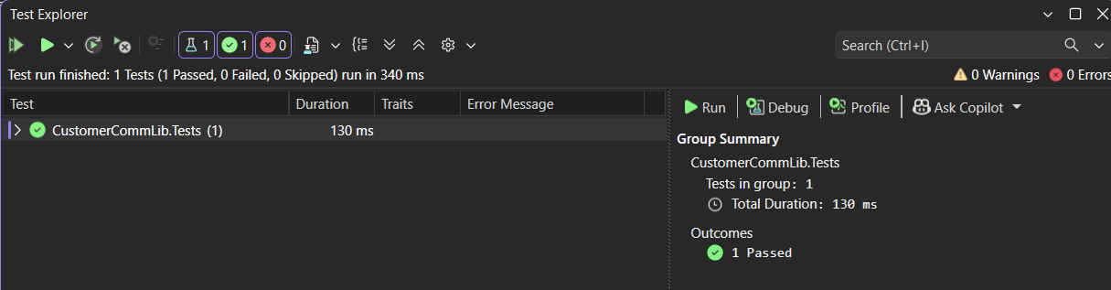

Task-2:
UnitTest2.cs
using CustomerCommLib;
using Moq;
using NUnit.Framework;
namespace CustomerCommLib.Tests
{
[TestFixture]
public class Tests
{
private Mock<IMailSender> mockMailSender;
private CustomerComm customerComm;

[OneTimeSetUp]
public void Init()
{
mockMailSender = new Mock<IMailSender>();
mockMailSender
.Setup(x => x.SendMail(It.IsAny<string>(), It.IsAny<string>()))
.Returns(true);
customerComm = new CustomerComm(mockMailSender.Object);
}
[TestCase]
public void SendMailToCustomer_ReturnsTrue()
{
bool result = customerComm.SendMailToCustomer();
Assert.That(result, Is.True);
}
}
}
